USING WEB PAGE DEVELOPMENT TO TEACH PROGRAMMING CONCEPTS
Alyce Brady and Kelly Schultz
Mathematics and Computer Science Department
Kalamazoo College
Kalamazoo, MI 49006
(616) 337-7065, (616) 337-7107
abrady@kzoo.edu, kschultz@kzoo.edu

ABSTRACT
In the context of a broad overview course we are providing an introduction to user interface design and basic programming concepts through the use of HTML and JavaScript. Given the graphical nature of the world wide web and the attention it is receiving in the press, students are motivated to learn about web page development. JavaScript is a programming language loosely based on C that can be used to bring activity and interactivity to the web pages. Since the language is embedded in HTML, students can produce interesting programs with impressive user interfaces quickly and easily. This allows us to introduce students to user interface design, programming concepts and constructs, and common algorithmic approaches in a way that the students perceive as fun, timely and useful.

THE COURSE
Since 1995 Kalamazoo College has offered Introduction to Computer Science, a course designed to meet the needs of students considering a major in computer science but also students who plan to never take another course in the discipline. The course provides an overview of the field of computer science from the concrete (binary numbers and circuits) to the abstract (algorithm analysis and computability). The course focuses on the general algorithmic approach to problem solving, system and user interface design, and the basic concepts of computer programming. Other topics include the history of computers, an introduction to several areas of computer applications including artificial intelligence, and the ethical and societal issues raised by the widespread use of computers.
We have deliberately chosen to do two things with this course. First of all, we do not encourage a distinction between computer science majors and non-majors. The course is aimed primarily at first and second-year students and we assume that these students are still sampling disciplines without having chosen a field of major study.
Our second deliberate choice is to teach a broad overview course rather than a programming course. This is because we feel that many people mistakenly equate computer science with computer programming. By widening the scope of the course to include various aspects of computer science (from hardware to theory), by emphasizing design, especially user interface design, rather than just programming, and by using a scripting language that most students have not already used, we attempt to create a level playing field between students with and without previous programming experience. For students who go on to major in computer science, this course provides a context for all their later, more narrowly defined courses. For students who never take another course in computer science, the course provides a broader, more realistic view of the discipline than does a traditional programming course. For both types of students the course provides a greater appreciation for the breadth of intellectual inquiry in the field, a sense of the conceptual and communication skills required in computer programming, and an awareness of the impact of computers on society.
Until the start of the 1997-98 academic year, we were using Decker and HirshfieldÕs The Analytical Engine: An Introduction to Computer Science Using HyperCard 2.1[4]. This book contains 9 modules (see Figure 1), one of which is user interface design using HyperCard authoring (stacks, buttons, fields), and one of which is computer programming using HyperTalk, the programming language underlying HyperCard. In our ten-week quarter, we have been devoting one week to HyperCard authoring and two weeks to
A History of Computing
Applications and Implications
Designing for Use
Programming
Program Translation
Hardware
Theory of Computation
Artificial Intelligence
Computers and Society
Figure 1: The Nine Modules from The Analytical Engine[4]
HyperTalk programming. Decker and HirshfieldÕs book includes laboratory exercises in each module; we scheduled a weekly lab of 1 hour and 40 minutes in addition to our three hours of lecture time.
Overall the Introduction to Computer Science course has been successful. The word among students is positive and the enrollment has quadrupled. The actual student evaluations have had two consistent messages, one positive and one negative. First, students were very positive about the effectiveness of the labs. Many felt that most of their learning occurred in lab. On the other hand, students were not happy with the choice of HyperCard and HyperTalk. They saw them as marginal applications that would not be useful to the students in the future. The instructors felt that by using HyperCard and HyperTalk the students were learning valuable skills and concepts in multimedia, hypertext, user interface design, and programming, but were unable to convince the students of this! Another complaint among students was that the labs focused too much on modifying existing applications rather than developing new ones, and that therefore the students had not learned how to program for themselves.
As a result of these student attitudes, we decided to revise the course during the summer of 1997. We were aware that Decker and Hirshfield were developing a new edition of The Analytical Engine[5], but the new book and some of the new labs would not be available by the 1997-98 academic year. Therefore we decided to develop our own curriculum and labs with the help of two students doing summer research with us. We had three goals for the new version of the course: to enhance the focus on user interface design, to continue the weekly labs while also introducing new mini-labs to be integrated into the lectures on programming topics, and to use web page development and JavaScript instead of HyperCard and HyperTalk.

USING JAVASCRIPT TO TEACH PROGRAMMING CONCEPTS

The Planning Stage
In our revised Introduction to Computer Science course we decided to introduce new programming constructs by integrating new Òmini-labsÓ of approximately 20 minutes into our lectures. In addition, we kept the weekly lab blocks to work on longer exercises. The mini-labs provide immediate hands-on interaction with new concepts. Each mini-lab provides a brief overview of one concept, an example of it in action and an exercise in which students apply the concept in the context of an on-going project. Closed labs, on the other hand, provide students with an opportunity to integrate concepts, again with detailed instructions but with fewer direct examples.
To address the concern of many students that they had not learned to develop their own programs, we decided that students should create each of the programs they work on from scratch. Each lab or mini-lab consists of starting a new program or modifying a program students have created previously. Three projects are used to teach students basic programming concepts: a personal home page with a guestbook feature for visitors to fill in; a simple “expert system” that asks a user questions and then gives advice on movies, books, types of beer, clothing styles, or some other domain of the student’s choosing; and an order form for a CD store.
Through these three programming projects the revised course introduces students to several topics central to computing: user interface design, programming concepts, and algorithms. To enhance the focus on user interface design we give reading assignments from ShneidermanÕs Designing the User Interface[7], ask students to evaluate the user interfaces of several well-known applications (such as Microsoft Word and Netscape Communicator), and include the consideration of user interface issues in the development and grading of all three programming projects.
To teach programming concepts, we use JavaScript. JavaScript is a programming language that can be used within HTML to bring activity and interactivity to web pages. As with HyperCard and HyperTalk, JavaScript's connection to HTML means that students can create complex user interfaces with much less effort than with most programming languages. Unlike HyperTalk, though, JavaScript syntax is loosely based on C; in particular, its support of expressions, arithmetic operations, if-statements, loops, and functions is quite similar to C. JavaScript is easy to learn yet provides a useful basis for students who want to learn other modern programming languages, such as C, C++ and Java.
Of the three programming projects, we use the first (the home page and guestbook) primarily to introduce new programming concepts and their syntax. In the second and third programming projects, however, we also introduce interesting algorithms that have applications throughout computer science. For the expert advice project, students develop a simple table-driven algorithm. In the CD order form project, students implement a selection sort algorithm. (Later in the course students have the opportunity to execute several different sorting algorithms and analyze their relative performance characteristics.)

Preparing Students for JavaScript Programming
Three labs precede the module on JavaScript Programming, providing students with useful background information. The first lab is a general introduction to a number of applications, including Word, Excel, PowerPoint, and Netscape Navigator. The Navigator exercise introduces students to the world wide web, to the concept of hypertext, and to some of the issues of user interface design. In the second lab students use a WYSIWYG web page editor (Netscape Composer in our case) to develop a simple home page that includes images, colors, and links to other pages, including a link to a resume they have previously created in Word. Before the third lab, we introduce students to HTML tags and JavaScript forms, buttons, and fields. In Lab 3 students use an HTML editor to add fields and buttons to their home page, creating a guestbook. By the end of the lab they have a text field in which a visitor can type their name, a selection menu from which to choose a country, and a text area for comments in their guestbook. We provide the program that transforms the data into a formatted mail message that is sent to the student.

Programming Concepts
JavaScript Òprograms,Ó or active web pages, are event-driven applications. That is, instead of having a single, main program call a number of sub-programs in a specified order (as happens in a procedural or functional program), or having a number of objects communicating through message-passing (as in an object-oriented program), JavaScript applications consist of functions that respond to user-driven events such as mouse clicks. The flow of execution is in large part under the control of the user rather than of the programmer. This distinction need not bother the student, especially one who has never programmed in another language, but it is something that the instructor should be aware of when planning the order in which to introduce new programming concepts. We recommend the following order:
- event handlers (i.e., functions)
- JavaScript objects and their attributes (within functions)
- variables, constants, arithmetic and string operators
- if and if-else statements
- arrays
- loops

Event Handlers
When a user clicks on a button, selects a menu item, or moves the mouse into a text field, it triggers an event that can be caught or ignored by the web page. Different JavaScript objects react to different events such as onClick or onLoad. The event handler can consist of a single command in an HTML tag or a complex series of commands implemented in JavaScript functions. We discuss event handlers and the syntax for simple functions with and without parameters in lecture, introduce comments, and then let students dive in to the first mini-lab, which is an extension to the guestbook web page that they have already created.
Mini-Lab #1: Add a function to your guestbook web page to ask a visitor to confirm that they want to sign in before the form submits their data to the guestbook formatter. (The complete instructions for the mini-labs, labs, and programming projects are available from [3])

JavaScript Objects and Their Attributes:
We introduce students to the HTML tags for the basic JavaScript objects that appear on a web form (buttons, menus, and fields) before they produce the first version of their guestbook in Lab 3. In that lab they also specify object attributes in the HTML tags. The syntax for referring to objects from within JavaScript functions is quite different, however. JavaScript uses a notation similar to C, C++, and several other object-oriented languages to refer to the sub-objects or attribute components of an object. Students must understand the object hierarchy of form elements within a web page (for example, a window contains a document, which contains a form, which contains form elements, which contain value attributes) in order to refer to JavaScript objects within functions in Mini-Lab #2.

Variables, Numeric Constants and Arithmetic:
Although JavaScript variables, unlike C variables, are not typed, they should be declared using the var keyword. JavaScript variables, numeric constants and arithmetic operators resemble those in C except that all numbers in JavaScript are treated as floating point.

Mini-Lab #2: Modify the signIn function to put the contents of the name and country objects into variables. This will make the actual call to confirm easier to read.
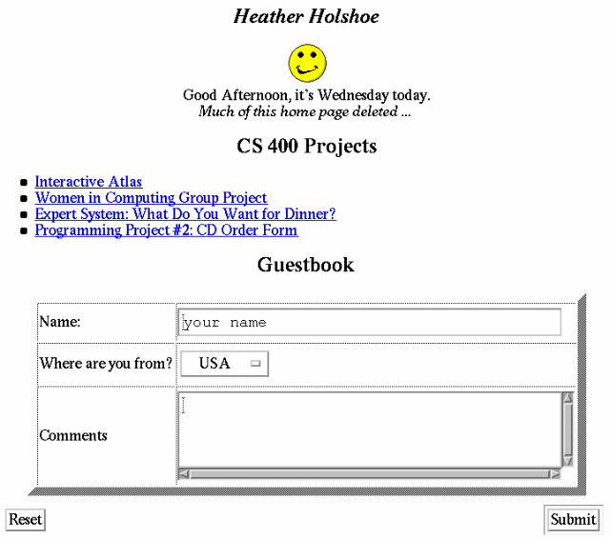
Figure 2: Sample Guestbook Web Page

If Statements, the JavaScript Date Object:
If and if-else constructs are exactly the same in JavaScript as in C. We have found that beginners often do not recognize the value of else until asked to describe the behavior of their code, regardless of the language. For example, what is the flow of execution in the following code if dayOfWeek is Saturday? If dayOfWeek is Sunday?
if ( dayOfWeek == ÒSundayÓ ) ...
if ( dayOfWeek == ÒMondayÓ ) ...
if ( dayOfWeek == ÒTuesdayÓ ) ...
Mini-Lab #3: Modify your home page so that it prints a different welcome message for each day of the week, with another message that varies depending on whether it is morning, afternoon, or evening.
At this point students are done with their home page and guestbook.

The Expert Advice Web Page:
With Lab #4 students begin the Expert Advice project. Before the lab we give a description of one or two real-life expert systems and introduce the concept of a decision tree. Next, we give a demonstration of a small system representing 15 questions and 16 answers. The lab entrance assignment for Lab #4 is for students to create a decision tree representing an area of ÒexpertiseÓ of their own choosing. In anticipation of Programming Project #1 we ask the students to make sure all leaves are the same distant from the root and to number the questions in their decision tree in breadth-first order. Students could also do the first part of Lab #4 (creating the user interface) before coming to lab, since it is really just a review of Lab #3.
Lab #4: Create the user interface for an advice program similar to the one in Figure 3. Given the current question number and the user’s response to that question (a Yes/No event), use if, else if and else statements to determine the next question or the final answer.

Arrays, Table-driven Algorithms:
JavaScript does not include explicit support for arrays, but programmers can create arrays using constructor functions. This programming project allows students to explore a simple table-driven algorithm using arrays. We describe in lecture how to traverse a full, complete binary tree stored in an array.
Programming Project #1: Create an array of 16 questions, but make the first question equal to the empty string. The other 15 questions should be the questions from your decision tree, in order. Create a second array of the 16 answers from your decision tree. Modify your project to determine the next question (or answer) based on the numerical relationships between a question and its two follow-up questions (or answers). (We start with an empty string in the question array because the formulae for calculating the left and right children of any node are simpler if the node numbers start at 1 rather than 0.)
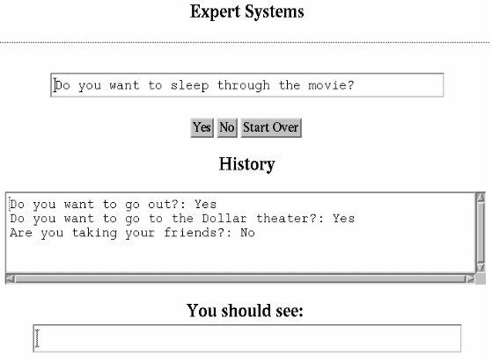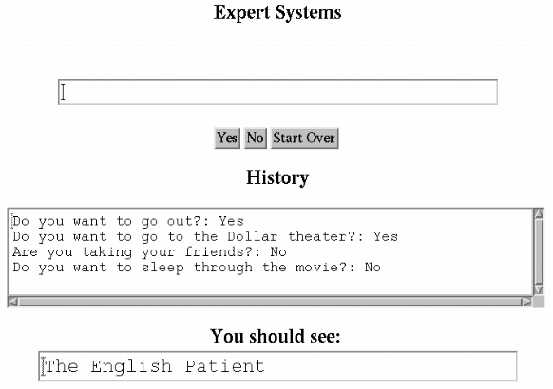
Figure 3: Sample Expert System (both questioning and giving the answer)

Loops and HTML Tables:
JavaScript uses the for, while, and do-while constructs from C. We primarily introduce loops through the use of for loops to step through arrays. The mini-lab for loops introduces the third programming project, the CD order form, which contains an array of information about CDs (see Figure 4 for an example).
Mini-Lab #5: Create a new HTML document in which you will build a table to store information about CDs in a CD store. Each row in the table should contain a CD title, the artist name, and a checkbox indicating whether the user wants to buy the CD. Build the table by writing a function that uses a loop to create each row separately. For now all the field in the table should be empty.

User-defined Objects:
JavaScript programmers can define user-defined objects using constructor functions. To actually create a new object, such as an array or record, students invoke the constructor function with the new operator.
Mini-Lab #6: Modify your CD order form to fill in the table with actual CD information. First, create an object constructor function to create an object containing CD information: artist, title, and bought (whether or not the user is buying the CD). Next, create an internal array to hold the information for 10 CDs. Then, modify the function that creates the table on the CD order form to display the corresponding attribute of each CD object.

Sorting:
The CD order form project provides an opportunity to introduce students to sorting, a classic computer science problem. We choose to introduce the selection sort algorithm. This is the one function that students do not write from scratch. Instead we provide a fully commented template containing the structure of the algorithm with key expressions missing. At each stage students fill in a missing expression, or several related expressions, and then run the algorithm. The template includes temporary output statements that display the behavior of the algorithm at that stage. Students compare the output to a description of expected results we provide for each stage before they go on to fill in the missing expression(s) in the next section of the algorithm.
Lab #5: Add a button to your CD table that will allow the user to sort the records by title. Read the template file for Lab 5 into your CD order form web page. Use the comments given and your knowledge of the selection sort to fill in the missing expressions. Test your program after filling in each set of expressions.
In their final programming exercise the students complete the CD order form application.
Programming Project #2: Modify the function sortByTitle() so that it prints the sorted CDs to the table. Create a new button and function that sorts the CDs by artist. Create a button to display the order when the user has finished buying CDs. Add graphics or text to the page to make it a better user interface. Add text to describe what users should do, align the order form and other buttons in an easy-to-read format and add an appropriate background.
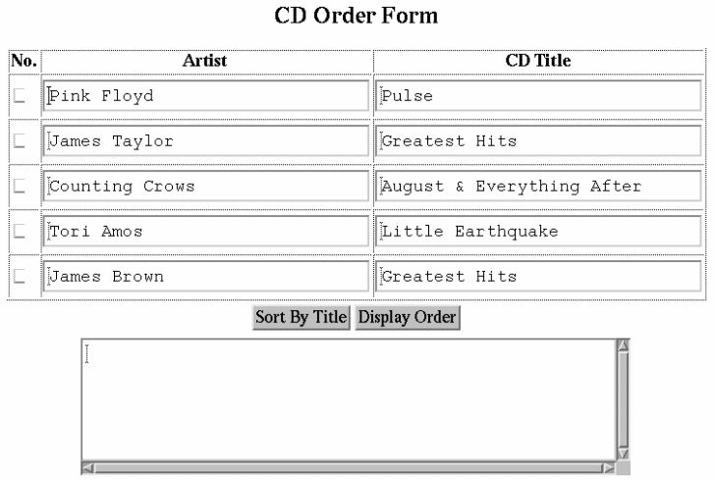
Figure 4: CD Order Form

OTHER WAYS TO INCORPORATE THE WEB
Since much of the focus of the revised Introduction to Computer Science course is on the web, it seems to make sense to incorporate the web, and information about graphical user interfaces in general, into the course. In addition to providing the usual instructor-generated material online, such as syllabus, bibliography, homework assignments, and news and announcements, we have created a Òclass portfolioÓ for each section of the class[3]. The class portfolio includes links to the studentsÕ home pages, guestbooks, expert advice pages, and CD order forms, and also several other projects. For example, early in the quarter groups of students create computer science history web sites around various topics such as Early Pioneers, the Personal Computer Revolution, and Artificial Intelligence. Students also complete an in-class group design project in which they develop a draft graphical user interface design for a complex multimedia application.
We have also decided to make copies of many of our lecture notes available online, particularly the lectures on JavaScript programming. In addition to the actual presentations used in class, the lecture notes include pointers to more detailed information on JavaScript provided by Netscape[6] and other organizations.

EXPERIENCE SO FAR
Overall, we think that JavaScript is a useful language for teaching basic programming concepts to students who are unfamiliar with them. For now JavaScript is rare enough in the high schools and is sufficiently different from C and C++ to level the playing field, at least to some extent, between incoming students with previous programming experience and those without. Students have shown enthusiasm for learning HTML and JavaScript, especially when the focus is on graphical user interfaces.
We feel that a number of elements are critical to achieving success in using JavaScript to teach programming concepts and, in particular, in using in-class mini-labs:
- The order in which new programming constructs are introduced is very important. We have traditionally taught variables, expressions, and simple and complex statements (i.e., conditional statements and loops) before functional decomposition. For the first offering of the revised course we moved the introduction of functions to before if statements, but this was not early enough. Because of the event-driven nature of JavaScript, we believe that functions are fundamental to creating even the simplest JavaScript programs and we have moved the discussion of them to the beginning of our module on programming.
- Labs require a lower student-teacher ratio than lectures, even when they have a narrow focus. We divide our class into two sections for our regularly scheduled labs and have a student assistant in each lab in addition to the professor. We did not have student help during the mini-labs the first quarter we taught the class. Since the mini-labs are scheduled during the normal lecture times, they include the entire class. This meant that during the first quarter our student-teacher ratio for mini-labs was four times higher than for the full labs. We have addressed this by having student lab assistants come to class during mini-labs.
- Labs and mini-labs must have well-written instructions. Mini-labs, especially, should be written as tutorials, as if students were going to be doing them on their own, since the amount of help an instructor can give any one student during a brief mini-lab is severely restricted. For that reason, also, mini-lab instructions should include relevant examples.
- Student preparation is critical. Lab entrance assignments that students must hand in to participate in lab can help to ensure student preparation.
- Even when mini-labs are very short it is difficult to integrate more than one into a single class session. The amount of time students require to finish a mini-lab will vary considerably, and both instructors and students are frustrated when some students are finishing previous labs while other students charge ahead.
- Labs and mini-labs require that the hardware and software be reliable.

SUMMARY AND CONCLUSIONS
We believe that web page development is a good technique for presenting educational concepts. Authoring tools for developing graphical user interfaces, such as HyperCard and WYSIWYG web page editors, allow students to create sophisticated programs fairly easily. Multimedia authoring and the event-driven paradigm are becoming increasingly common as application development moves to higher levels of abstraction. JavaScript is still rare enough among graduating high school students that it serves to level the playing field, at least to some extent, between those students who have previous programming experience and those who do not. Furthermore, JavaScript is close enough to C that students who go on to learn other C-based languages will find that they can build on their experience with JavaScript. Finally, students are motivated to learn because they see web page development as timely, relevant, exciting, in the news, and in the job advertisements.

ACKNOWLEDGMENTS
We would like to thank Kevin Arnold and Andrew Seidl, for their hard work in developing new labs and mini-labs, and also the students and teaching assistants who participated in the pilot course of our revised Introduction to Computer Science during the fall of 1997.

BIBLIOGRAPHY

[1] Aitken, Web DeveloperÕs Guide to JavaScript and VBScript, Coriolis Group Books, 1996.

[2] Brady, Involving students in creating a multimedia class portfolio. In Proceedings of the 5th Annual Conference on Multimedia in Education and Industry, Charleston, SC, July 1996.

[3] Brady and Schultz, Introduction to Computer Science Home Page, http://max.cs.kzoo.edu/CS400/, 1997.

[4] Decker and Hirshfield, The Analytical Engine: An Introduction to Computer Science Using HyperCard 2.1, PWS Publishing Company, 1994.

[5] Decker and Hirshfield, The Analytical Engine, PWS Publishing Company, 1998.

[6] Netscape Communications Corporation, JavaScript Handbook, http://home.netscape.com/eng/mozilla/Gold/handbook/javascript/index.html, 1996.

[7] Shneiderman, Designing the User Interface, 3rd Edition, Addison Wesley Longman, 1997.

